**Basic Scheduling**

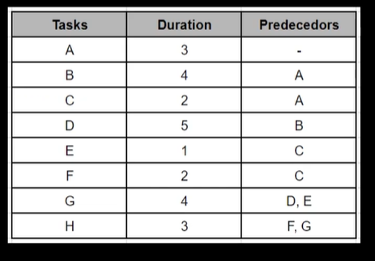

* Task A should finish to start task B
* Task A should finish to start task C
* Task B should finish to start D
* Task C should finish to start E and F

Tasks E and D can start at the same time

* Task F and task G should finish to start H

Tasks F and G can start at the same time

**The duration will be 19 days**